THE RTD
History
The same year that Seebeck made his discovery about thermoelectricity, Sir Humphrey Davy announced that the resistivity of metals showed a marked temperature dependence. Fifty years later, Sir William Siemens proffered the use of platinum as the element in a resistance thermometer. His choice proved most propitious, as platinum is used to this day as the primary element in all high-accuracy resistance thermometers. In fact, the Platinum Resistance Temperature Detector, or PRTD, is used today as an interpolation standard from the oxygen point (-182.96°C) to the antimony point (630.74°C).
Platinum is especially suited to this purpose, as it can withstand high temperatures while maintaining excellent stability. As a noble metal, it shows limited susceptibility to contamination.
The classical resistance temperature detector (RTD) construction using platinum was proposed by C.H. Meyers in 1932. He wound a helical coil of platinum on a crossed mica web and mounted the assembly inside a glass tube. This construction minimized strain on the wire while maximizing resistance.
Although this construction produces a very stable element, the thermal contact between the platinum and the measured point is quite poor. This results in a slow thermal response time. The fragility of the structure limits its use today primarily to that of a laboratory standard.
Another laboratory standard has taken the place of Meyers’ design. This is the bird-cageelement proposed by Evans and Burns. The platinum element remains largely unsupported, which allows it to move freely when expanded or contracted by temperature variations.
Strain-induced resistance changes over time and temperature are thus minimized, and the bird-cage becomes the ultimate laboratory standard. Due to the unsupported structure and subsequent susceptibility to vibration, this configuration is still a bit too fragile for industrial environments.
A more rugged construction technique is shown in Figure 37. The platinum wire is bifilar wound on a glass or ceramic bobbin. The bifilar winding reduces the effective enclosed area of the coil to minimize magnetic pickup and its related noise. Once the wire is wound onto the bobbin, the assembly is then sealed with a coating of molten glass. The sealing process assures that the RTD will maintain its integrity under extreme vibration, but it also limits the expansion of the platinum metal at high temperatures. Unless the coefficients of expansion of the platinum and the bobbin match perfectly, stress will be placed on the wire as the temperature changes, resulting in a strain-induced resistance change. This may result in a permanent change in the resistance of the wire.
There are partially supported versions of the RTD which offer a compromise between the bird-cage approach and the sealed helix. One such approach uses a platinum helix threaded through a ceramic cylinder and affixed via glass-frit. These devices will maintain excellent stability in moderately rugged vibrational applications.
TYPICAL RTD’s (FIgures 36 and 37)
Metal Film RTD’s
In the newest construction technique, a platinum or metal-glass slurry film is deposited or screened onto a small flat ceramic substrate, etched with a lasertrimming system, and sealed. The film RTD offers substantial reduction in assembly time and has the further advantage of increased resistance for a given size. Due to the manufacturing technology, the device size itself is small, which means it can respond quickly to step changes in temperature. Film RTD’s are presently less stable than their hand-made counterparts, but they are becoming more popular because of their decided advantages in size and production cost. These advantages should provide the impetus for future research needed to improve stability.
Metals - All metals produce a positive change in resistance for a positive change in temperature. This, of course, is the main function of an RTD. As we shall soon see, system error is minimized when the nominal value of the RTD resistance is large. This implies a metal wire with a high resistivity. The lower the resistivity of the metal, the more material we will have to use.
Table 6 lists the resistivities of common RTD materials.
METAL |  | RESISTIVITY OHM/CMF  (cmf = circular mil foot)
Gold Silver Copper Platinum Tungsten Nickel Au Ag Cu Pt w Ni |  | 13.00  8.8  9.26  59.00  30.00  36.00

Table 6
Because of their lower resistivities, gold and silver are rarely used as RTD elements. Tungsten has a relatively high resistivity, but is reserved for very high temperature applications because it is extremely brittle and difficult to work.
Copper is used occasionally as an RTD element. Its low resistivity forces the element to be longer than a platinum element, but its linearity and very low cost make it an economical alternative. Its upper temperature limit is only about 120ºC.
The most common RTD’s are made of either platinum, nickel, or nickel alloys. The economical nickel derivative wires are used over a limited temperature range. They are quite non-linear and tend to drift with time. For measurement integrity, platinum is the obvious choice.
Resistance Measurement
The common values of resistance for a platinum RTD range from 10 ohms for the bird-cage model to several thousand ohms for the film RTD. The single most common value is 100 ohms at 0ºC. The DIN 43760 standard temperature coefficient of platinum wire is α = .00385. For a 100 ohm wire, this corresponds to + 0.385 ohms/ºC at 0ºC. This value for α is actually the average slope from 0ºC to 100ºC. The more chemically pure platinum wire used in platinum resistance standards has an α of +.00392 ohms/ohm/ºC.
Both the slope and the absolute value are small numbers, especially when we consider the fact that the measurement wires leading to the sensor may be several ohms or even tens of ohms. A small lead impedance can contribute a significant error to our temperature measurement.
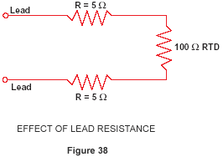
A ten ohm lead impedance implies 10/.385 ≈ 26ºC error in measurement. Even the temperature coefficient of the lead wire can contribute a measurable error. The classical method of avoiding this problem has been the use of a bridge.
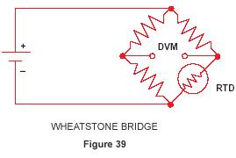
The bridge output voltage is an indirect indication of the RTD resistance. The bridge requires four connection wires, an external source, and three resistors that have a zero temperature coefficient. To avoid subjecting the three bridge-completion resistors to the same temperature as the RTD, the RTD is separated from the bridge by a pair of extension wires:
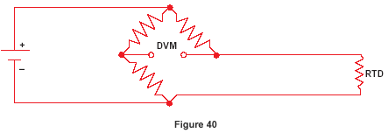
These extension wires recreate the problem that we had initially: The impedance of the extension wires affects the temperature reading. This effect can be minimized by using a three-wire bridge configuration:
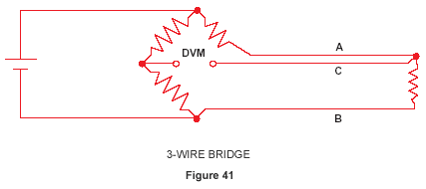
If wires A and B are perfectly matched in length, their impedance effects will cancel because each is in an opposite leg of the bridge. The third wire, C, acts as a sense lead and carries no current.
The Wheatstone bridge shown in Figure 41 creates a non-linear relationship between resistance change and bridge output voltage change. This compounds the already non-linear temperature-resistance characteristic of the RTD by requiring an additional equation to convert bridge output voltage to equivalent RTD impedance.
4-Wire Ohms - The technique of using a current source along with a remotely sensed digital voltmeter alleviates many problems associated with the bridge.
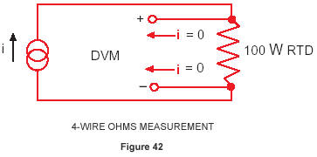
The output voltage read by the dvm is directly portional to RTD resistance, so only one conversion equation is necessary. The three bridge-completion resistors are replaced by one reference resistor. The digital voltmeter measures only the voltage dropped across the RTD and is insensitive to the length of the lead wires.
The one disadvantage of using 4-wire ohms is that we need one more extension wire than the 3-wire bridge. This is a small price to pay if we are at all concerned with the accuracy of the temperature measurement.
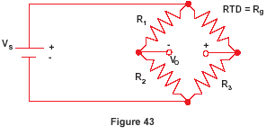
3-Wire Bridge Measurement Errors
If we know V_{S} and V_{O}, we can find R_{g} and then solve for temperature. The unbalance voltage V_{o} of a bridge built with R₁ = R₂ is:
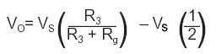
If R_{g} = R₃, V_{O}= 0 and the bridge is balanced. This can be done manually, but if we don’t want to do a manual bridge balance, we can just solve for R_{g} in terms of V_{O}:
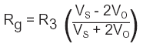
This expression assumes the lead resistance is zero. If R_{g} is located some distance from the bridge in a 3-wire configuration, the lead resistance R_{L} will appear in series with both R_{g} and R₃:
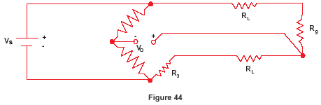
Again we solve for R_{g}:
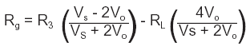
The error term will be small if V_{o} is small, i.e., the bridge is close to balance. This circuit works well with devices like strain gauges, which change resistance value by only a few percent, but an RTD changes resistance dramatically with temperature. Assume the RTD resistance is 200 ohms and the bridge is designed for 100 ohms:
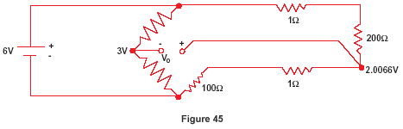
Since we don’t know the value of R_{L}, we must use equation (a), so we get:
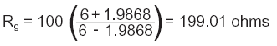
The correct answer is of course 200 ohms. That’s a temperature error of about 2.5ºC.
Unless you can actually measure the resistance of R_{L} or balance the bridge, the basic 3-wire technique is not an accurate method for measuring absolute temperature with an RTD. A better approach is to use a 4-wire technique.
Resistance to Temperature Conversion
The RTD is a more linear device than the thermocouple, but it still requires curve-fitting. The Callendar-Van Dusen equation has been used for years to approximate the RTD curve:
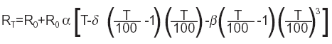
Where:
R_{T} | = | Resistance at Temperature T
R_{o} | = | Resistance at T = 0ºC
Α | = | Temperature coefficient at T = 0ºC ((typically +0.00392Ω/Ω/ºC))
Δ | = | 1.49 (typical value for .00392 platinum)
Β | = | 0 T > 0  0. 11 (typical) T < 0
The exact values for coefficients α , β, and δ are determined by testing the RTD at four temperatures and solving the resultant equations. This familiar equation was replaced in 1968 by a 20th order polynomial in order to provide a more accurate curve fit. The plot of this equation shows the RTD to be a more linear device than the thermocouple.

